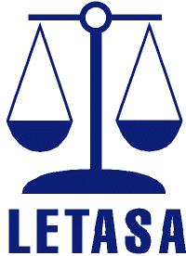ABN - 14 852 335 677
OBJECTS OF LETASA
- To promote and provide support for legal
education in schools in South Australia
- To publish and disseminate legal
education resources
- To link with the broader legal community
for teachers and students

AGM
AGENDA
To be held on Friday 21st August 2020
at the University of South Australia, Pridham Hall

Business Session: Chaired by Commenced at

Present:
Apologies:

- Minutes:

MOTION: The Minutes from the last meeting are a clear and accurate record of the proceedings.
- Moved:
- Seconded:
- Proposed Constitutional Change to be voted at the 2021 AGM.

- President’s Report: Rick Sommariva
MOTION: The President’s report be accepted
- Moved:
- Seconded:

- Treasurer’s Report: Sharon Snaith

MOTION: The Treasurer’s report is a clear and accurate account of LETASA’S financial position and should be accepted.
- Moved:
- Seconded:

- Election of the 2020 -2021 Committee
The following office bearers to be elected:
- President: Rick Sommariva elected 2019 for two-year term
- Vice President:

Treasurer:

Secretary:

Membership Secretary:

IT Officer:

Publication Distribution Officer:
- Country Liaison:

The following members were duly elected to the LETASA COMMITTEE of 2019 – 2020 – (not less than 5 members of the Association and a maximum resolved at the AGM – s 6.2 Legal Education Teachers Association Constitution)

Next AGM Meeting 2021

- LIFE MEMBERSHIP AWARD

- BOB TUCKER MEMORIAL AWARD

LETASA SERVICE AWARD

ANY OTHER BUSINESS

Meeting concluded at

